**GOMARKET APP SETUP DOCUMENT**

**(Note – Please use only Flutter - 1.22.4)**

**App Icon**(user>images>logos>logo_store.png)

Rename your logo with (logo_store)

Size 512x512 only

Format png only

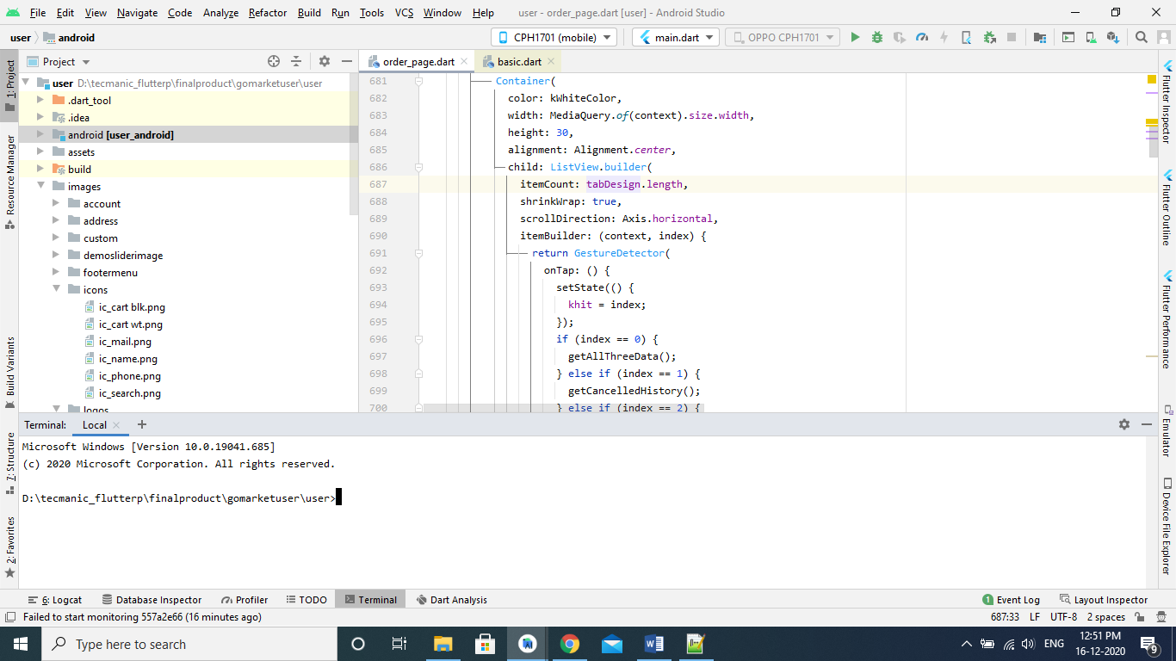

path should be your root folder.  
(Note-> if your full path not seen in your terminal then close it and again click on terminal)

then type and hit enter  
flutter pub get

then again type and hit enter  
flutter pub run flutter_launcher_icons:main  
  
  
**APPNAME**(app>res>values>strings.xml)

<string name="app_name">Put your App's new name here</string>  
  
(under project folder lib>baseurl>baseurl.dart)

appname = Put your App's new name here  
  
**BaseUrl**  
(user>lib>baseurl>baseurl.dart)

var baseUrl = "https://thecodecafe.in/hybrid_resturant/api/";  
var imageBaseUrl = "https://thecodecafe.in/hybrid_resturant/";

Notification Icon

(app>res>drawable>logo_user.png)

Rename your logo with (logo_user)

Size 512x512 only

Format png only

**App Theme Main Color**

(user>lib>Themes>color.dart)  
Color kMainColor = Color(0xffe8657e);

Change color code

**CHANGE PACKAGE NAME**Go to terminal  


path should be your root folder.  
(Note-> if your full path not seen in your terminal then close it and again click on terminal)

then type and hit enter  
flutter pub get

then again type and hit enter  
flutter pub run change_app_package_name:main com.demo.demo  
  
then open the android module and delete pervious package but before copy all files from old package to new one. See the attach screen

Important Point or Notice.  
Please once check only gradle version is same in all outer used library.  
please share the screenshoot (with blue mark)  
  
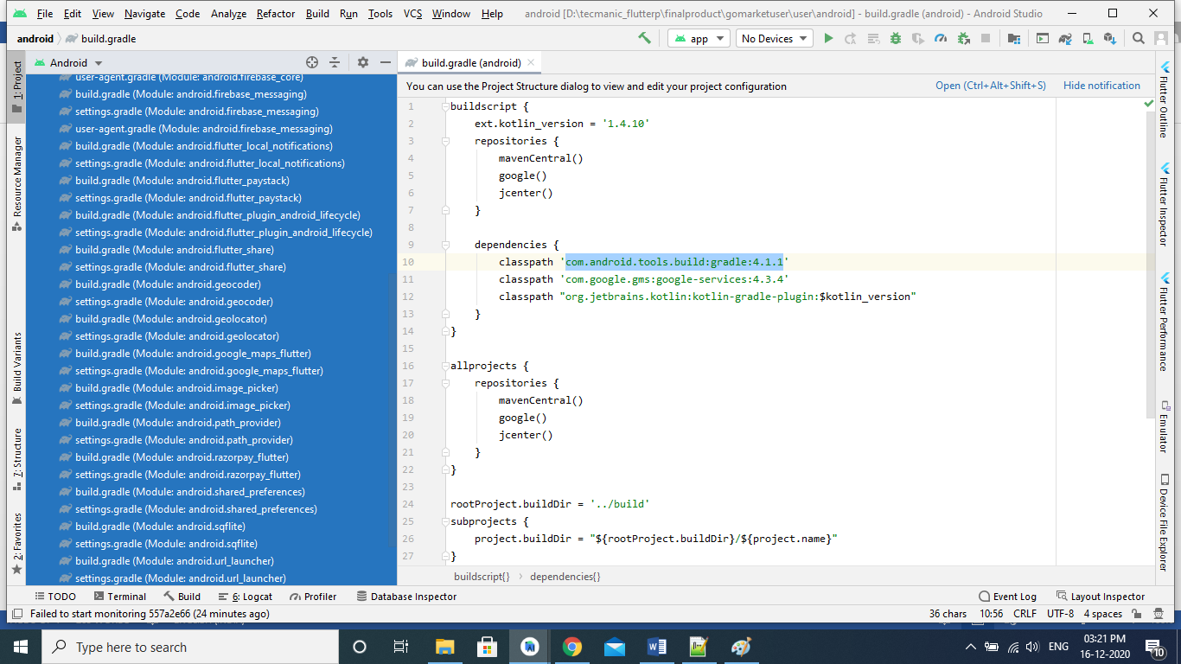

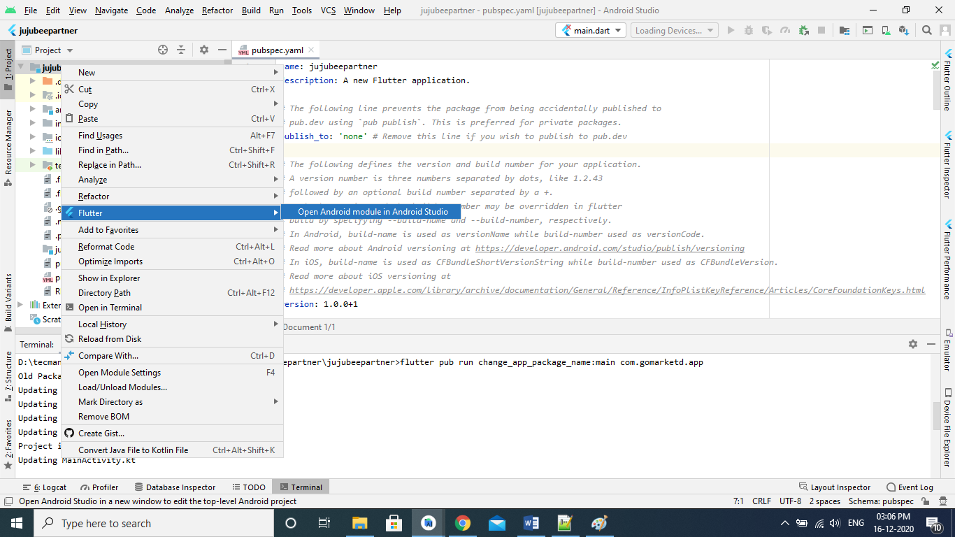

open your app on android module

then delete your old package with name gomarketdemo.vendor but copy all file from old package to other new one package.

For your reference please see the screenshot below with blue area.  
  
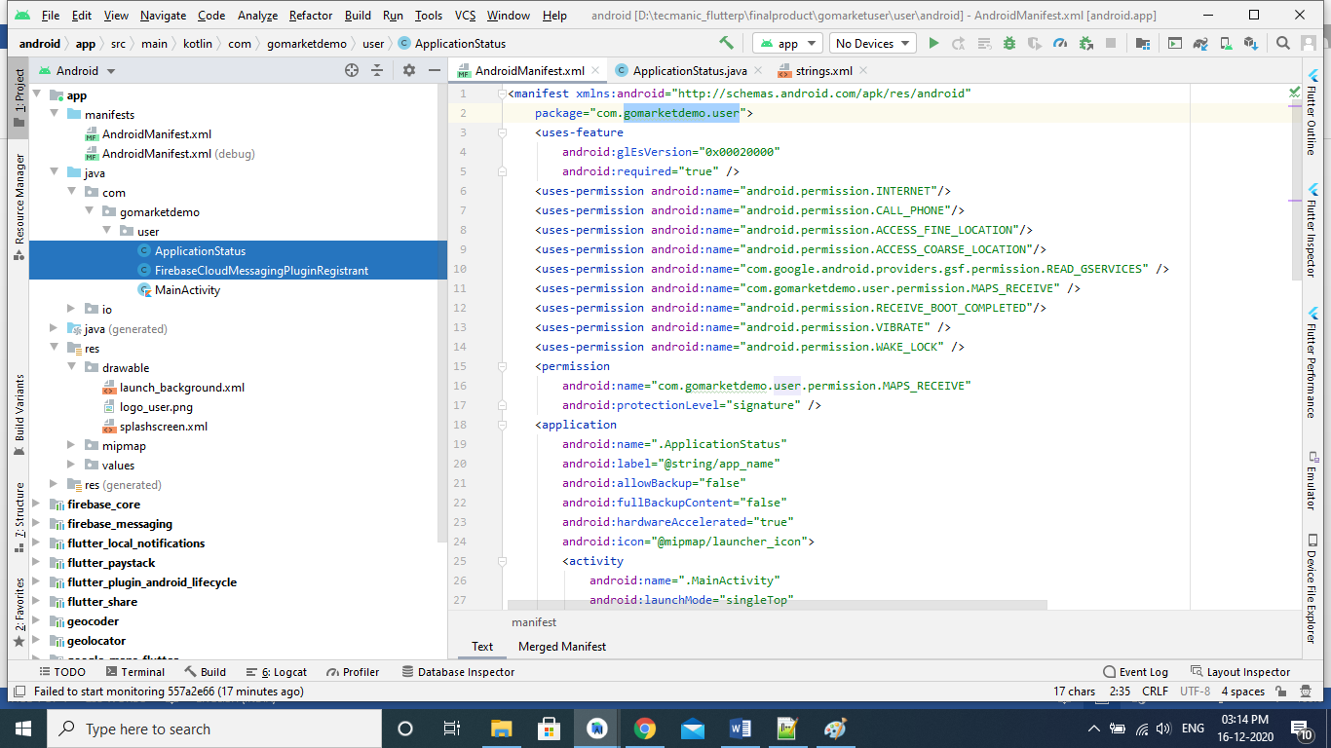

Please select ApplicationStatus.java file and do some changes  
  
FirebaseOptions options = new FirebaseOptions.Builder()  
 .setApplicationId("com.demo.demo")

.setProjectId("demo-59eb0")

.setApiKey("put your key").build();

(

Applicationid means -> your package name  
project id -> find from firebase console.  
apikey -> same as map key

)

FirebaseApp.*initializeApp*(this,options,"demo");

In place of demo please update your app name given in firebase console.

Then setup this file in manifest file under   
(app>manifest>AndroidMainfest.xml) replace line no. 9 or line android:name=".ApplicationStatus" see the screenshot for your reference given below.

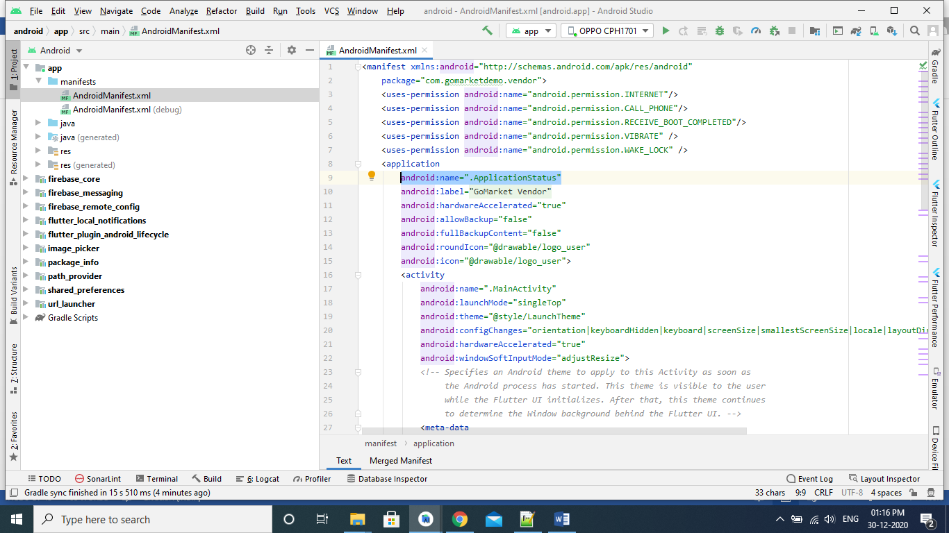  
  
**GOOGLEJSON FILE SETUP**

Follow this link to setup your project on firebase and cloude console

<https://docs.kii.com/en/samples/push-notifications/push-notifications-android-fcm/create-project/>

then download your google_services.json file in from firebase and put your file into with given instruction below.  
  
  
Click on Dropdown seen in screenshot the select project   
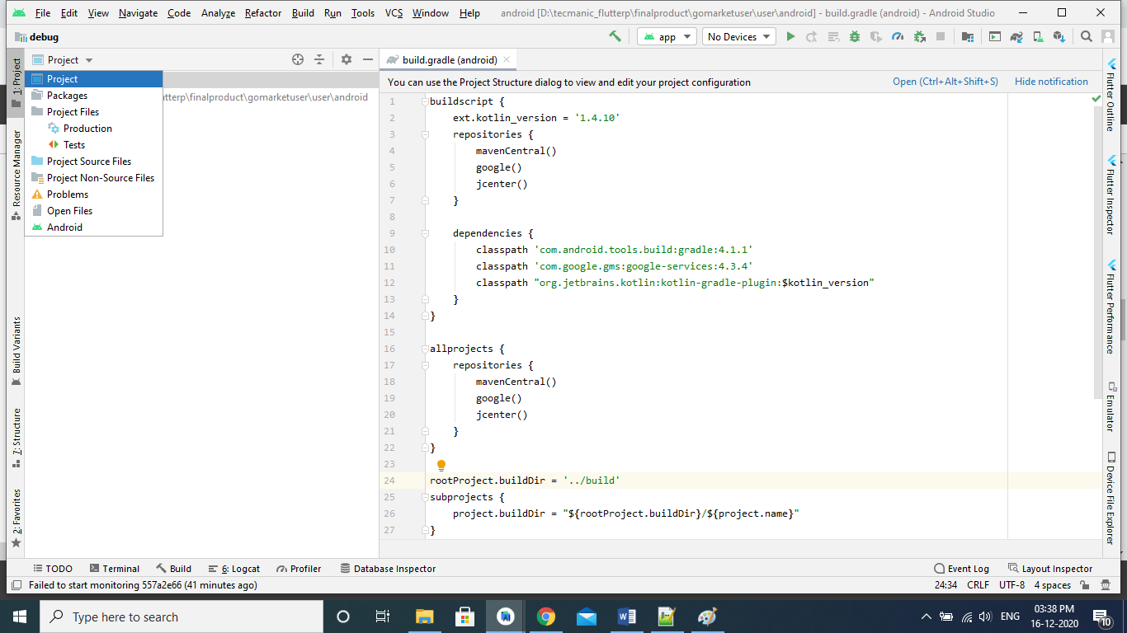

Then select android folder (there are two android folder here then select 2nd one)  
then select app and paste your file google-services.json here.  
  
android>app> google-services.json

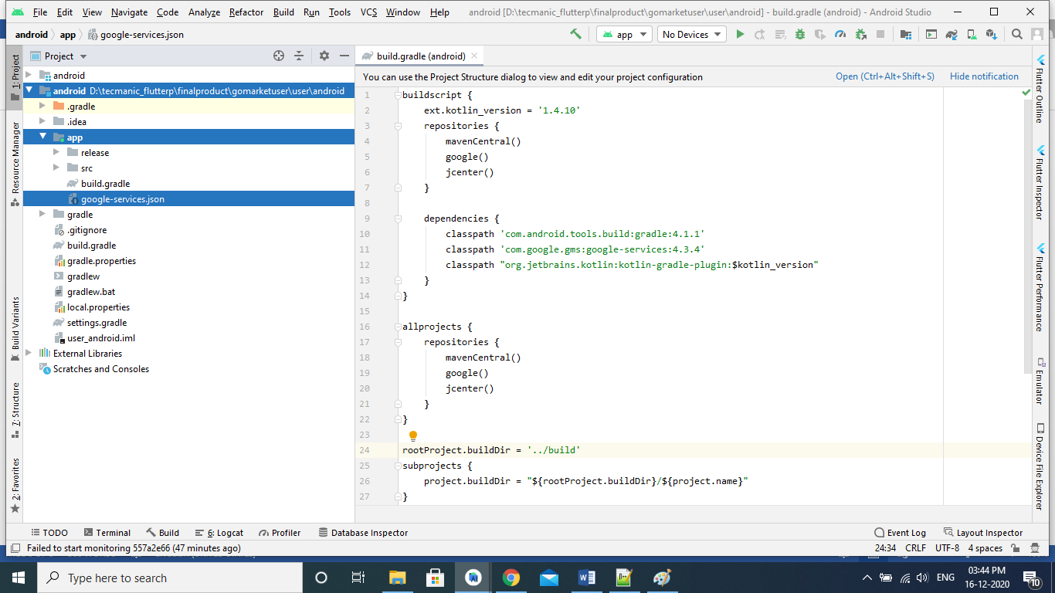

Signing Your App in Android Studio

To sign your app in release mode in Android Studio, follow these steps:  
  
1- On the menu bar, click Build > Generate Signed APK.

2-On the Generate Signed APK Wizard window, click Create new to create a new keystore. If you already have a keystore, go to step 4.

3- On the New Key Store window, provide the required information as shown in figure Your key should be valid for at least 25 years, so you can sign app updates with the same key through the lifespan of your app.

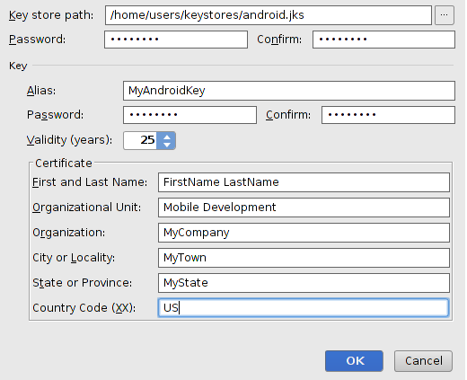

4- On the Generate Signed APK Wizard window, select a keystore, a private key, and enter the passwords for both. Then click Next.  
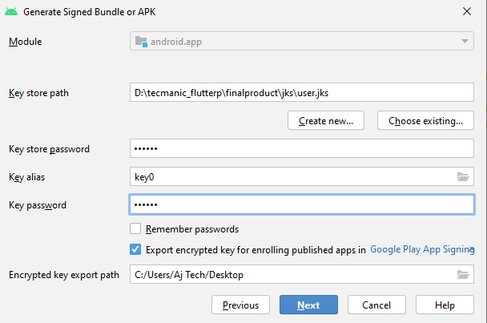  
  
  
5- On the next window, select a destination for the signed APK and click Finish.

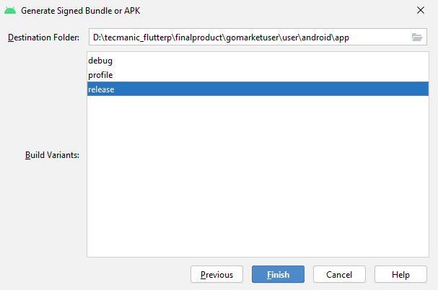

SIGNED SHA1  
  
Go to your Java bin directory via the command:  
  
C:\Program Files\Java\jdk1.7.0_71\bin>

Now type in the below command in your command window   
  
keytool -list -v -keystore c:\users\James\.android\demo.jks -alias key0 -storepass android -keypass android

**DEBUG SHA1**  
Click on Gradle on the far right side:  
  
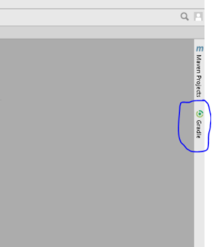

Click on the refresh icon, and you will see the name of the app:  
  
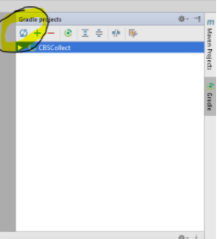  
Click on Tasks -> Report -> Signing Report:  
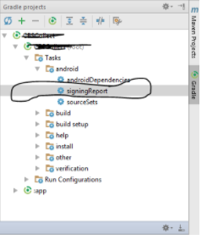  
  
Find the SHA-1 key on the bottom part in the console:  
  
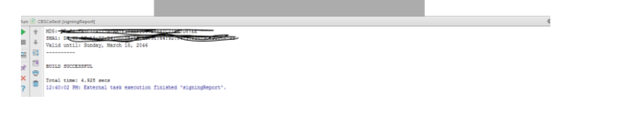

**VERSION CODE AND VERSION NAME**

How to upgrade version in flutter  
  
1. Change the version in given bluemark in screenshot   
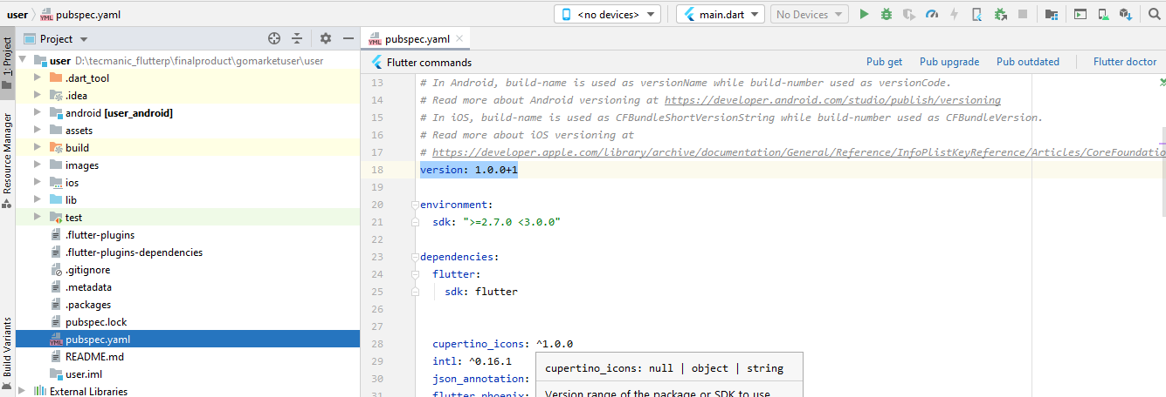  
  
2. Then click on pub get to keep the changes. Refer screenshot red mark button

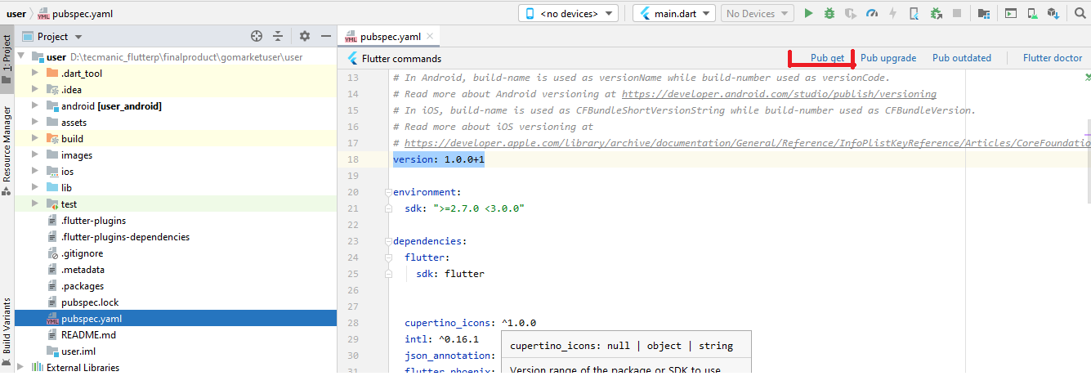

Then open terminal and type and enter   
flutter pub get && flutter run

And for ios please type and enter this also  
flutter build ios --release-name --release-number

Note if these not work then please do this in case of any trouble .  
Go to android module see screenshot  


And build.gradle seen in screenshot and

Increase the version code and version name as per your requirement.  
  
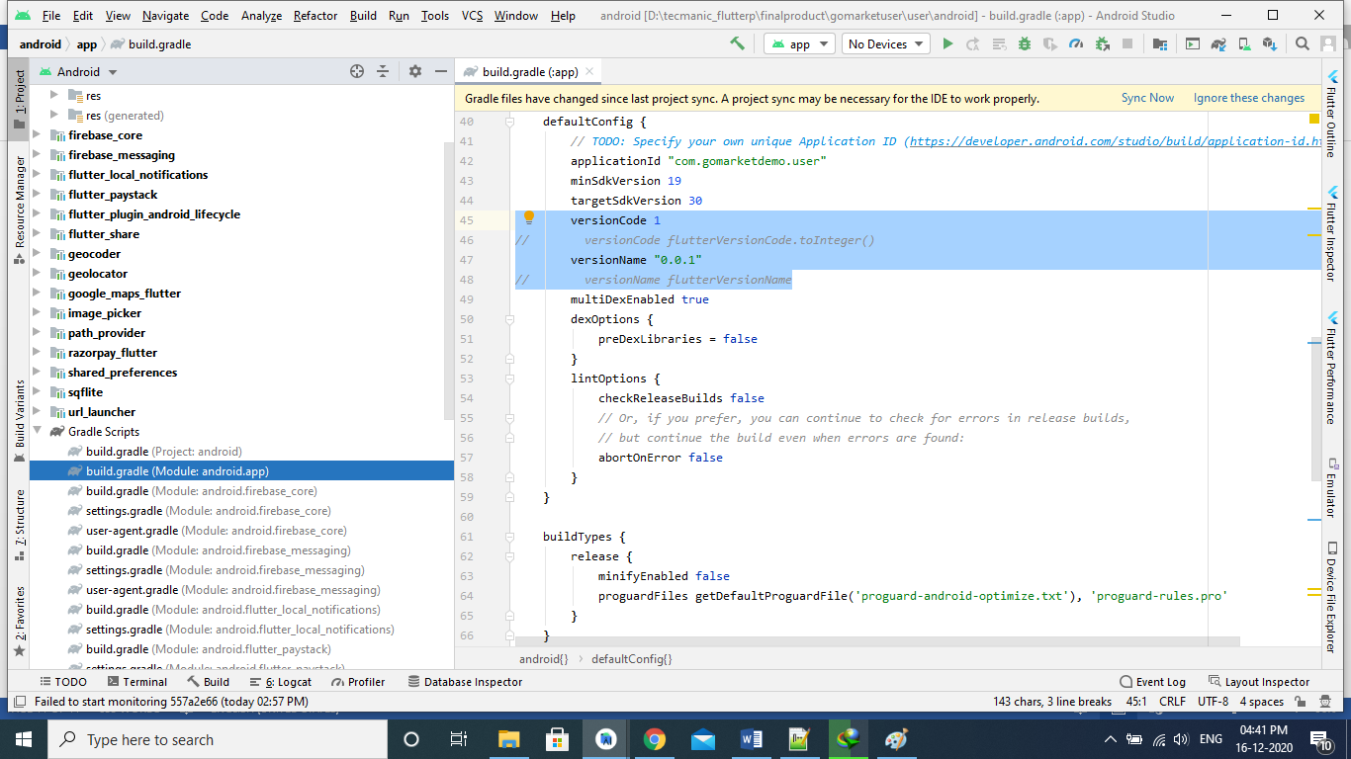

**IOS SECTION**(Runner>Info.plist)  
Location Permission in Info.plist  
Please put all permission in Info.plist seen in screenshoot.  
  
  
**PUSH NOTIFICATION**

## Download your GoogleService-Info.plist from firebase console after creating your project or app in firebase console. FIREBASE PROJECT CREATION Please follow the link to create your project into firebase <https://firebase.google.com/docs/ios/setup> ****APNS CERTIFICATE SETUP** please follow the link to create APNS certificate.** https://levelup.gitconnected.com/custom-push-notification-in-ios-swift-5-210552643e86